Ariadne Labs Spark Grant Program
Letter of Interest
Directions:
Please use the template on the following page for your LOI to make our assessment easier. Please limit your LOI response to a total of one to two pages, anything beyond two pages will not be considered.

Submit the completed LOI, as well as any questions, to sparkgrants@ariadnelabs.org.

Spark grant Application criteria

Ariadne Labs Spark Grant applicants are assessed along four primary criteria. Please consider these criteria as you develop your Spark Grant application and participate in our selection process.

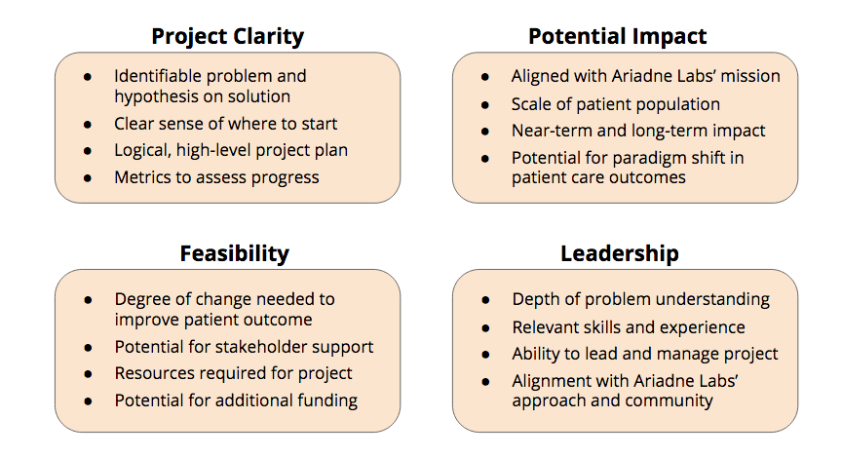

Spark Grant LOI Template- March 2020

Project Title
Proposed By
Harvard School Affiliation
Home Institution

Problem: What is the major problem in healthcare delivery you plan to address (including patient population that will be affected)?

History: Please include a brief history of your work and how it informs the project you plan to accomplish at Ariadne Labs.

Objectives: How do you plan on using this grant from Ariadne Labs to support your work towards a new intervention or capacity aimed at solving the problem? What will be the final deliverable for the project?

Needs: Please include a preliminary idea of any staff or resources you will need and any that you already have, and an estimate of the total project budget. Please note Spark Grants can only cover salaries up to the NIH cap. (Ariadne Labs Innovation Platform is available to help estimate costs, email sparkgrants@ariadnelabs.org).

Risks/Challenges: What do you foresee as being the biggest obstacle(s) that could affect the outcome or adoption of your objectives?

Additional Information: Is there any additional information that we should know?

