Dean’s Innovation Grants in Health Care Delivery:
A collaboration with Ariadne Labs Spark Grant Program
Letter of Interest
Directions:
Please use the template on the following page for your LOI in order to make our assessment easier. Please limit your LOI response to a total of one to two pages; anything beyond two pages will not be considered except references which may be on a third page. Please note a full budget is not required at this stage. PI’s invited to submit a full application will be provided a budget template at that time.

Submit the completed LOI as an attachment to sparkgrants@ariadnelabs.org. Please also use that email for questions regarding the program.

Spark Grant Application Criteria

Ariadne Labs Spark Grant applicants are assessed along four primary criteria. Please consider these criteria as you develop your Spark Grant application and participate in our selection process.

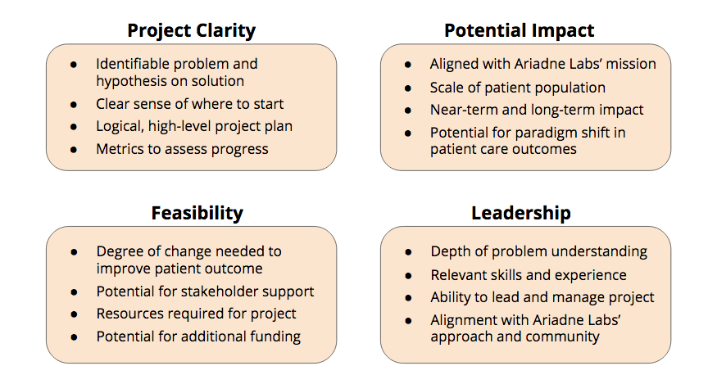

Dean’s Innovation Grants in Health Care Delivery
Spark Grant LOI Template

Project Title
Proposed By
Home Institution & Department

Problem: What is the major problem in healthcare delivery you plan to address (including patient population that will be affected)?

History: Please include a brief history of your work and how it informs the project you plan to accomplish at Ariadne Labs.

Objectives: How do you plan on using this grant from Ariadne Labs to support your work towards a new intervention or capacity aimed at solving the problem? What will be the final deliverable for the project?

Needs: Please include a preliminary idea of any staff or resources you will need and any that you already have, and an estimate of the total project budget up to a maximum of $80,000 in total costs to the investigator. If you have preliminary ideas of which Ariadne Labs platforms, resources, or other teams you would like to engage with, please detail those here – this support is included in the $20,000 direct costs allocated to Ariadne.

Risks/Challenges: What do you foresee as being the biggest obstacle(s) that could affect the outcome or adoption of your objectives?

Additional Information: Is there any additional information that we should know?

